- Mark the following statements as true or false
  - Every node in a linked list has two components: one to store the relevant information and one to store the address.
    - True
  - In a linked list, the order of the elements is determined by the order in which the nodes were created to store the elements.
    - True
  - In a linked list, memory allocated for the nodes is sequential.
    - False
  - In a linked list, typically, the link field of the last node points to itself.
    - False (It’s typically null)
  - Suppose the nodes of a linked list are in the usual info-link form and current points to a node of the linked list. Then current = current.link; advances current to the next node in the linked list.
    - True
  - To insert a new item in a linked list, create a node, store the new item in the node, and insert the node in the linked list.
    - True
  - To build a linked list forward, the new node is inserted at the end of the list.
    - True
  - A single linked list can be traversed in either direction.
    - False
  - In a linked list, nodes are always inserted either at the beginning or at the end because a linked list is not a random-access data structure.
    - False
  - The head pointer of a linked list should not be used to traverse the list.
    - True
  - The two most common operations on iterators are ++ and * (the dereferencing operator).
    - True
  - The function initializeList of the class linkedListType initializes the list by only setting the pointers first and last to nullptr
    - True
  - The function search of the class unorderedLinkedList searches the linked list sequentially, while the function search of the class ordered-LinkedList searches the list using a binary search algorithm because the data in an orderedLinkedList object is sorted.
    - False
  - A doubly linked list can be traversed in either direction.
    - True
- Describe the two typical components of a single linked list node.
  - A node has a link and a value, the link connects it to the next node and the value stores some information
- What is stored in the link field of the last node of a nonempty single linked list?
  - The last node typically contains a null pointer
- Suppose that first is a pointer to a linked list. What is stored in first?
  - First contains the memory address of the first node of the linked list
- Suppose that the fourth node of a linked list is to be deleted, and p points to the fourth node? Why do you need a pointer to the third node of the linked list?
  - You need a pointer to the third node so that you can change the third node to point to the fifth node and delete the fourth node. Otherwise you would break the chain and sever the links
- What is the output, if any, of each of the following C++ statements? (For each part, use the same list in Figure 16-50.)
  - cout << p→info;
    - 12
  - q = p→link;

cout << q->info << " " << current→info;
    - 92 65
  - cout << current→link→info;
    - 80
  - trail = current->link->link;

trail->link = nullptr;

cout << trail→info;
    - 46
  - cout << last→link→info;
    - Undefined behavior
  - q = current->link;

cout << q→link→link→info;
    - 5
- What is the value of each of the following relational expressions?
  - p->link->link == current
    - True
  - first->link->link->info == 92
    - True
  - temp->link == 0
    - False
  - last->link == nullptr
    - True
  - list->link == p
    - True
  - p->link->link->link->info == temp→info
    - False
- What are the effects, if any, of each of the following C++ statements?
  - trail = temp->link;

trail->link = nullptr;

delete last;

last = trail;
    - This deletes the last node
  - temp->link = last;
    - This links temp to last, thereby bypassing the second to last node. However, the second to last node still exists in memory, just unable to access it from another node.
  - first->info = 58;
    - This sets the info field of the first node to 58
  - q = current->link;

current->link = temp;

delete q;
    - This deletes the node after current and correctly links the current node to the node after to keep the linked list intact
  - q = p->link->link->link;

q->info = 60;
    - This changes the info field in the node 3 steps after p to equal 60
  - p->link = temp;
    - This sets the link for p to temp, thereby skipping two nodes in the middle of the linked list and severing it without deallocating that memory properly
- Write C++ statements to do the following.
  - Set the info of the third node to 24
    - p→link→info = 24;
  - Make q point to the node with info 80
    - q = current→link
  - Advance first to point to the next node.
    - first = first->link
  - Make trail point to the node before current.
    - trail = p->link
  - Make p point to an empty list.
    - p = nullptr
  - Set the value of the node before last to 54.
    - temp→link→info = 54
  - Write a while loop to make first point to the node with info 5.
    - while(first→info != 5){ first = first→link}
- Mark each of the following statements as valid or invalid. If a statement is invalid, explain why.
  - p = list→link;
    - Valid
  - first = list;
    - valid
  - temp->link = nullptr;
    - valid (but causes a memory leak)
  - current->link = temp→info;
    - invalid (sets a pointer to an int)
  - p = *last;
    - invalid (sets a pointer equal to a node rather than the address of a node)
  - first = 90;
    - invalid (sets a pointer equal to an int rather than an address of a node)
  - p->link->info = current→info;
    - valid
  - current->info = temp→link;
    - invalid (sets an int equal to a pointer)
  - *list = *temp;
    - valid (but would create a memory leak)
  - temp->link = last→link→link;
    - invalid (dereferences a null pointer)
  - cout << trail→link→link→info;
    - invalid (trail is a null pointer)
- How does the function insertFirst of the class unorderedLinkedList differ from the function insertFirst of the class orderedLinkedList
  - insertFirst in an unordereLinkedList simply creates a new node and inserts it before the first node. insertFirst in an orderedLinkedList doesn’t really apply because any node that’s inserted must be put in the right place in the list. You can’t really choose where you put it.
- Consider the following C++ statements. (The class unorderedLinkedList is as defined in this chapter.) What is the output of this program segment?
  - This code outputs an error because it attempts to delete a node that does not exist
- Suppose the input is [input]. What is the output of the following C++ code? (The class unorderedLinkedList is as defined in this chapter.)
  - The original list would be: 16, 120, 64, 40, 12, 45, 35, 83, 23, 11, 98. The program would throw an error after attempting to delete values that do not exist in the copied list (33 & 58).

Draw the UML diagram of the class doublyLinkedList as discussed in this chapter.
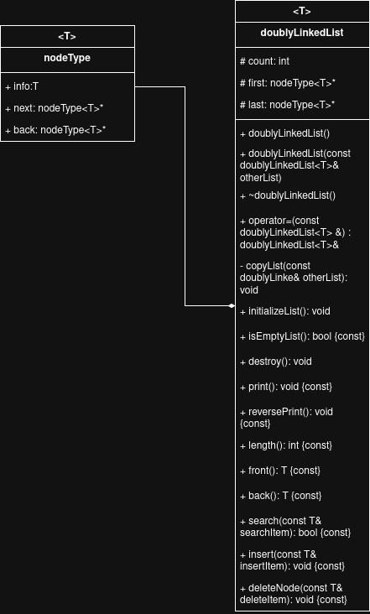

Draw the UML diagram of the class dvdType of the Programming Example DVD Store.
